**Network Task**

Answers

*Get me the IP address of a particular domain (*[*guvi.in*](http://guvi.in)*).*

* 172.67.70.207
* 104.26.5.88
* 104.26.4.88

We can get the Ip address using Ping [guvi.in](http://guvi.in), dig [guvi.in](http://guvi.in) , nslookup [guvi.in](http://guvi.in)

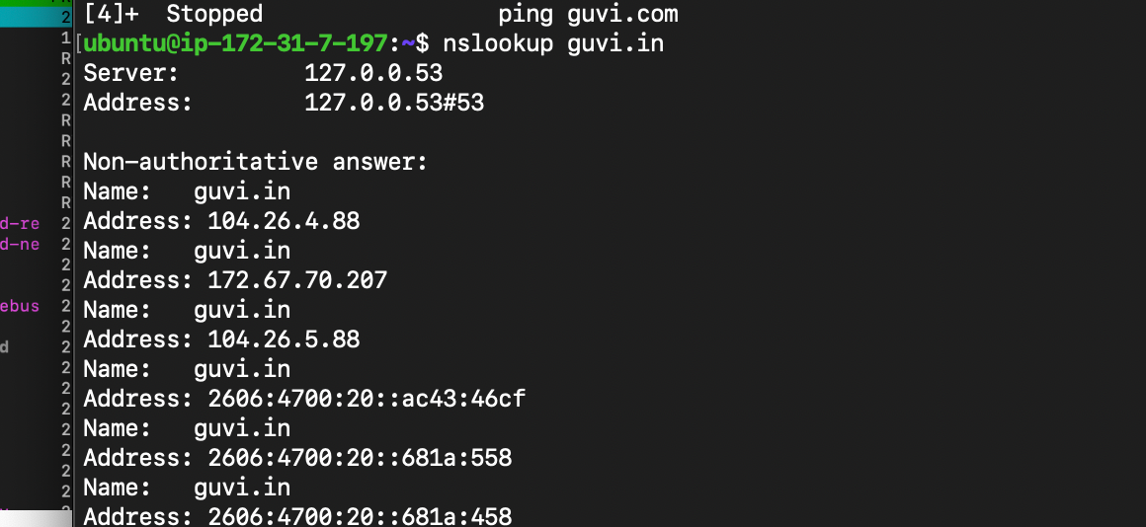

*How do I find my CPU/memory usage of my server?*

htop

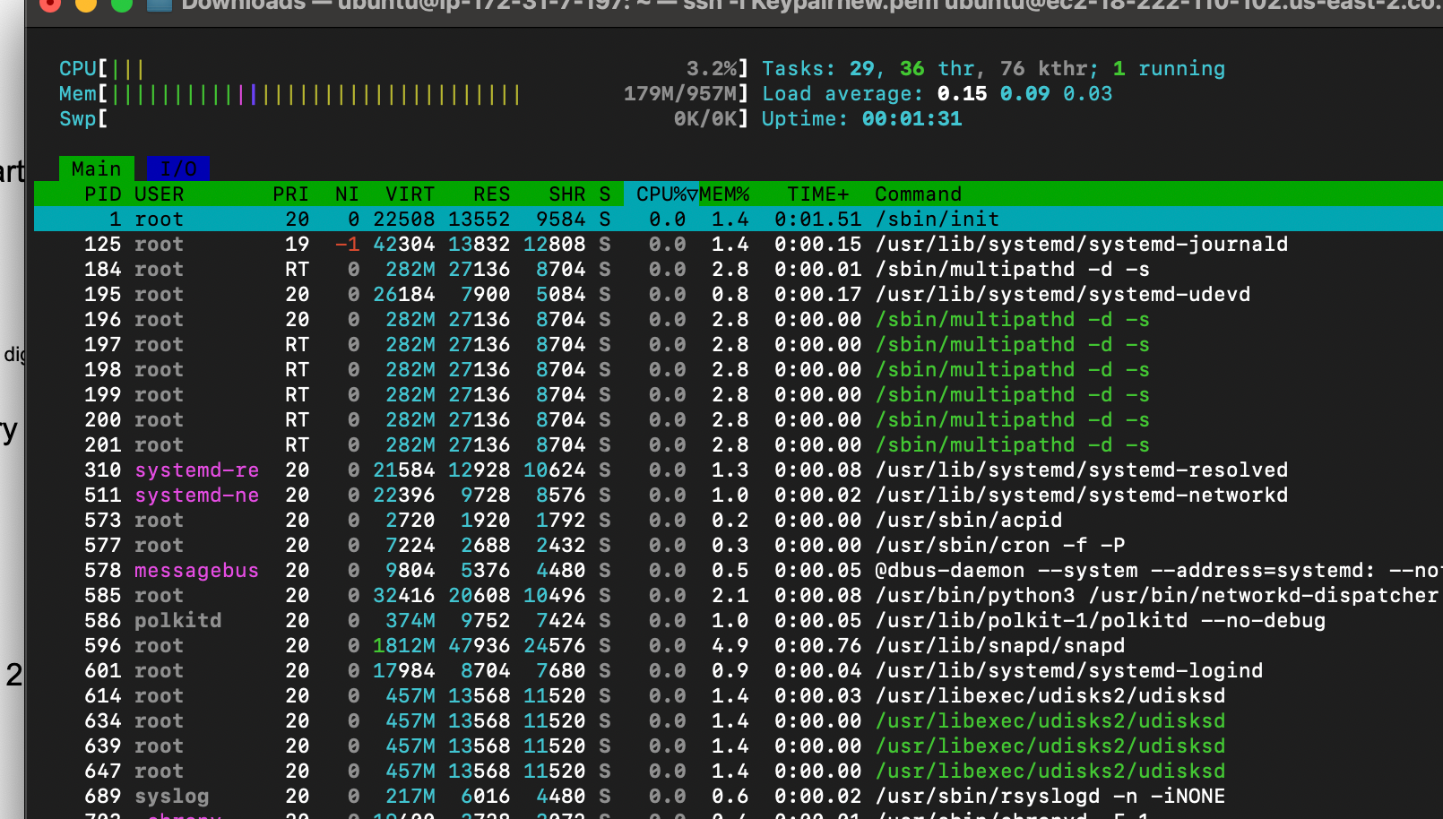

free -h - To see output in GB or MB



***Test the connectivity between 2 nodes?***

There are many ways to test the connectivity, the most simple step is

Ping , in which Node A will be device in which the ping command is running and Node B will be ip address that is entered on Ping command

Example : ping 172.67.70.207 ([guvi.in](http://guvi.in))

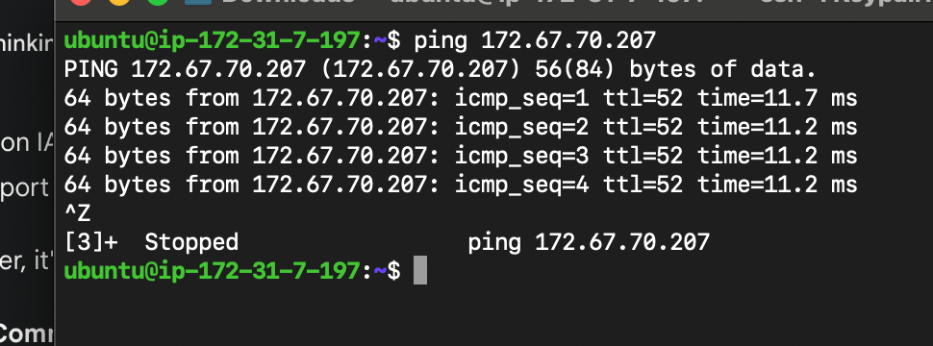

Traceroute, is an another option,

Example : traceroute 172.67.70.207.

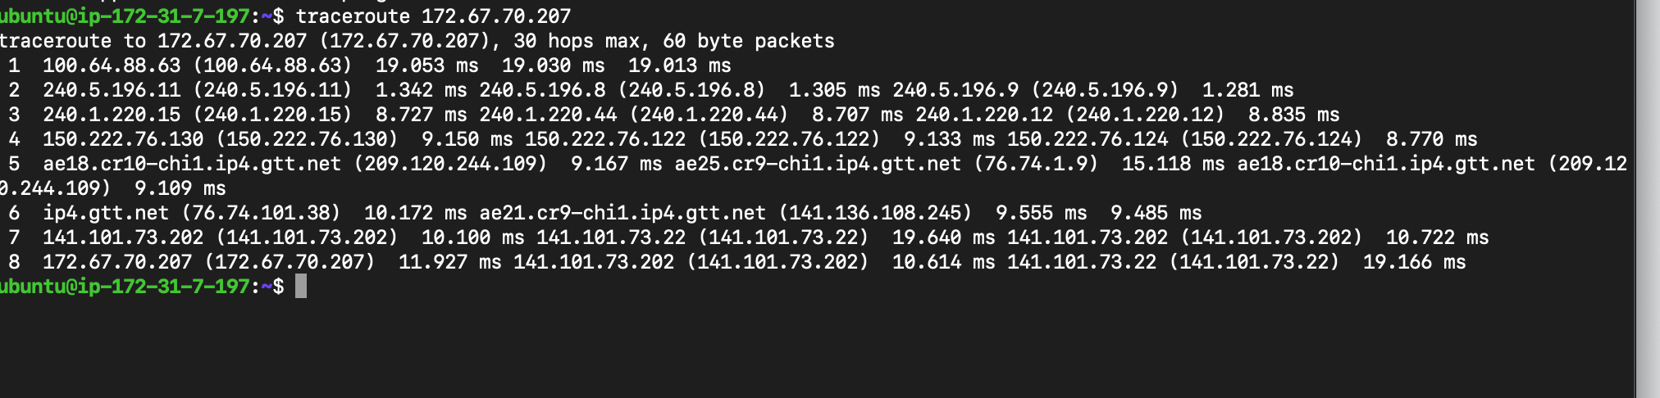

***2.I have deployed an application in guvi.com:9000, and logs show my app is running, but I’m unable to view the page. Check whether my port is open or not ?***

Answer : Port 9000 is closed

Explanation:

First step is to find the ip address of [guvi.com](http://guvi.com)

nslookup [guvi.com](http://guvi.com) - 104.21.79.166

Next check if the port is open or not

Use command nmap [guvi.com:9000](http://guvi.com:9000)

PORT STATE SERVICE

80/tcp open http

443/tcp open https

8080/tcp open http-proxy

8443/tcp open https-alt

